Sibusiso Mathonsi – 202339171

Strategic Specification and Phase 2 Architectural Blueprint for Cloud-Native SME Inventory Systems
The modern retail environment is characterized by a high degree of volatility and a transition toward omnichannel complexity, creating a significant operational burden for Small and Medium Enterprises (SMEs) that lack the technological infrastructure of larger conglomerates.¹ Research into the current state of SME inventory management reveals a pervasive reliance on manual tracking and batch-processing systems, which results in a data synchronization lag of fifteen to thirty minutes.¹ This inefficiency directly correlates with inaccurate inventory records, stock losses, and capital lock-in, ultimately eroding the financial sustainability of the enterprise.¹ To address these structural vulnerabilities, the proposed system adopts a cloud-native, microservices-based architecture designed for real-time synchronization and rapid deployment.¹ This report details Phase 2 of the system development, encompassing business process engineering, non-functional and functional requirement specification, Unified Modeling Language (UML) structural and behavioral documentation, and the strategic work breakdown for implementation.

Business Process Engineering and User Task Mapping
The core of digital transformation in retail lies in the precise translation of high-level business processes into granular user tasks that can be supported by automated workflows.⁵ For an SME, the transition from a "rule of thumb" approach to a systematic tracking model requires mapping every operational touchpoint—from customer interactions to back-end warehouse logistics.¹ Inefficient inventory management often stems from a lack of visibility into these processes, where data entry errors in one department propagate throughout the supply chain.¹

Tactical Mapping of Core Retail Processes
The following analysis decomposes the primary retail processes into user-centric tasks and system-level actions. This mapping is essential for ensuring that the technical solution aligns with the daily operational realities of staff members and provides a "single source of truth" across all sales channels.¹

Business Process | User Role | User Tasks and System Interactions
Process Returns | Cashier | The customer returns an item; the cashier verifies the receipt and condition of the item; the cashier scans the return barcode into the POS; the cashier processes the refund or credit; the system updates local and global inventory levels instantly; the system publishes a "Stock Returned" event to the analytics service.⁷
Sales Transaction | Cashier | The cashier scans items at the Point of Sale; the system validates pricing and available stock; the cashier applies discounts or loyalty points; the customer provides payment (cash/card); the cashier issues a receipt; the system deducts stock and publishes an "Order Created" event.⁷
Inventory Audit | Warehouse Staff | The system triggers a scheduled cycle count; the staff member locates the item via the mobile application; the staff scans the bin and item barcodes; the staff enters the physical count; the system reconciles the count against recorded levels; the manager reviews and approves any discrepancies.⁸
Receiving Goods | Warehouse Staff | The staff unloads a shipment from the supplier; the staff scans the delivery barcode; the staff counts items against the purchase order (PO); the staff flags damages or shortages in the system; the system updates stock-on-hand; the system closes the PO and triggers payment alerts.¹³
Replenishment | Store Manager | The system generates a low-stock alert based on reorder points; the manager reviews demand forecasting data; the manager selects the preferred supplier; the manager approves the auto-generated purchase order; the system transmits the PO via EDI or email to the vendor.⁸
Online Order Fulfillment | Warehouse Staff | The system receives an order from the e-commerce platform; the staff member receives a picking notification on a mobile device; the staff retrieves items based on the system-optimized pick path; the staff scans items into the packing station; the system generates a shipping label and updates the customer.⁴
The mapping of the "Process Returns" workflow illustrates the transition from a simple financial transaction to an integrated inventory event.⁹ By ensuring that the system updates inventory the moment a cashier processes a refund, the enterprise eliminates the possibility of "ghost stock"—inventory that appears available but is physically missing—or "hidden stock" that is back in the store but not yet recorded.¹

Operational Implications of Task Granularity
The decomposition of processes into tasks highlights the critical role of standardized location naming and coding conventions.⁸ For SMEs operating in multi-site environments, misplaced and overlooked products represent significant missed sales opportunities.¹² Warehouse mapping facilitates precise inventory tracking and optimized pick paths, which are essential for reducing labor costs—the most intensive operation in manual warehouses.¹⁴ By utilizing mobile-first interfaces for warehouse staff, the proposed system addresses the "complexity fear" that often bars SMEs from adopting advanced technology, providing intuitive visual aids and scannable barcode integration.¹

Non-Functional Requirements and Quality Standards
Non-functional requirements (NFRs) specify how well a system must perform its intended functions, defining the quality attributes that ensure long-term effectiveness and user satisfaction.³ For a cloud-native retail application, these requirements are benchmarked against the ISO 25010 standard, which provides a comprehensive framework for evaluating software product quality.¹⁸ The following NFRs represent the technical targets necessary to support the functional capabilities of the system and ensure resilience during peak demand periods.

Performance Efficiency and Capacity
Retail operations, particularly in an e-commerce context, are highly sensitive to latency; industry research indicates that every 100 milliseconds of delay can result in a 1% loss in sales.¹⁷
- Time Behavior: The system must ensure that API response times for 95% of requests remain below 200 milliseconds.¹⁷ Search results within the inventory catalog should appear within 500 milliseconds to prevent user frustration.¹⁷
- Resource Utilization: Through the use of serverless computing (e.g., AWS Lambda or Google Cloud Functions), the system must optimize resource consumption, scaling computing power to zero during periods of inactivity and expanding instantly to meet high-volume transactional demand.¹
- Capacity: The infrastructure must be capable of handling a 200% increase in traffic during promotional events without degrading response times.¹⁷ This is achieved through horizontal scaling, where additional container instances are automatically provisioned when CPU utilization exceeds 70%.¹⁷

Reliability and Availability
Reliability refers to the probability that a system will operate without failure for a specified duration in a target environment.²² For a critical business application like inventory management, high availability is non-negotiable.
- Availability: The system targets an uptime of 99.95%, allowing for no more than 4.38 hours of unplanned downtime annually.¹⁷ This is supported by multi-availability zone deployments and robust failover mechanisms.¹
- Fault Tolerance: The microservices architecture must employ "bulkhead" patterns and "circuit breakers" to isolate failures.¹ If a non-essential service, such as the reporting or analytics service, fails, the core sales and inventory tracking functions must remain operational.¹
- Recoverability: In the event of a catastrophic failure, the system must support a Recovery Time Objective (RTO) of 60 seconds and a Recovery Point Objective (RPO) of near-zero for all transactional data through synchronous database replication.¹⁷

Security and Auditability
In a retail environment, protecting sensitive customer data, financial transactions, and supplier information is paramount.¹
- Confidentiality and Integrity: All data in transit must be protected using TLS 1.3, while data at rest must be encrypted using AES-256.¹ Role-Based Access Control (RBAC) ensures that only authorized personnel can access or modify specific datasets.¹
- Accountability: The system must maintain immutable audit logs for every user action and inventory movement.¹ This ensures that any discrepancies or unauthorized activities can be traced back to the specific user and timestamp, satisfying both internal control and legal compliance requirements.¹⁹
- Authenticity: Implementation of Multi-Factor Authentication (MFA) and JWT-based session management ensures that the identity of every user and service is verified before access is granted.¹

Maintainability and Portability
To avoid the technical debt associated with legacy monolithic systems, the proposed solution prioritizes ease of modification and environment independence.¹
- Modularity: The architecture is composed of independent microservices that manage their own private data stores.¹ This allows developers to modify or upgrade individual services without impacting the rest of the system, reducing the risk of regressive errors.¹⁹
- Analyzability and Testability: The system must incorporate distributed tracing and centralized logging to enable rapid diagnosis of operational issues.¹ Pre-built CI/CD pipelines automate testing and deployment, ensuring that new features meet quality benchmarks before release.¹
- Portability and Adaptability: By utilizing containerization (Docker) and orchestration (Kubernetes), the system must be capable of running across various cloud providers (AWS, Azure, GCP) or hybrid environments without requiring major rewrites of the core logic.¹⁷

Functional Requirements: Input-Process-Output (IPO) Modeling
Functional requirements describe the specific tasks the system must perform to meet business goals.³ The Input-Process-Output (IPO) model provides a systematic framework for detailing these requirements by identifying the data that enters the system, the computations or transformations performed, and the resulting outputs.³¹ The proposed architecture decomposes these functions across eight core microservices.¹

Core Inventory Service
The Inventory Service acts as the "system of record" for all physical stock, maintaining real-time accuracy across multiple locations.¹

Component | Specification
Input | Barcode data from receiving; POS sale events; Return requests; Inventory adjustment entries; Stock transfer requests.⁷
Process | Validate barcodes; Deduct/add stock based on event type; Perform optimistic locking to manage concurrent updates; Check inventory levels against reorder thresholds; Record audit trail entry.¹
Output | Updated stock levels; Real-time inventory status for sales channels; Low-stock alerts; Transactional audit logs.⁴

Order Management Service (OMS)
The OMS orchestrates the lifecycle of orders from placement to final fulfillment, coordinating interactions between the inventory and payment services.¹

Component | Specification
Input | Customer order data (items, quantities, destination); Payment success/failure status; Shipping labels; Tracking numbers.²⁶
Process | Validate order integrity; Call Inventory Service to reserve stock; Monitor payment lifecycle; Route order to appropriate fulfillment center; Update order status (Pending, Shipped, Delivered).¹
Output | Order confirmations; Packing slips; Invoices; Fulfillment triggers; Delivery tracking updates for the customer.²⁶

Analytics and Forecasting Service
This service leverages historical sales data and machine learning to predict future demand, assisting managers in optimizing stock levels.¹

Component | Specification
Input | Minimum 24 months of historical sales; Inventory turnover rates; Supplier lead times; Promotional calendars; Market trends.⁸
Process | Execute time-series forecasting models (e.g., Simple Moving Average, Exponential Smoothing); Calculate Economic Order Quantity (EOQ); Determine optimal safety stock levels; Identify seasonal fluctuations.¹
Output | Demand forecasts; Recommended reorder points; Safety stock requirements; Profitability reports; Stockout risk warnings.¹
For the calculation of the reorder point (), the system utilizes the formula:
where represents average daily demand, represents lead time in days, and represents safety stock.¹ To optimize order sizes, the Economic Order Quantity () is calculated as:

where is annual demand, is order cost, and is carrying cost per unit.¹

Supplier and Procurement Service
This service automates the replenishment process by managing relationships with vendors and generating purchase orders.¹

Component | Specification
Input | Low-stock triggers; Supplier price lists; Vendor lead times; Purchase Order approval from management.¹²
Process | Evaluate supplier performance metrics; Calculate total landed cost; Generate and transmit Purchase Orders; Track shipment from vendor to warehouse.¹³
Output | Open and Closed Purchase Orders; Supplier scorecards; Landed cost analysis reports; Replenishment status updates.¹⁶

Notification and Integration Services
The Notification Service manages automated alerts, while the Integration Service utilizes the Adapter Pattern to bridge internal models with external vendor APIs.¹

Service | Input | Process | Output
Notification | Event triggers (e.g., "Out of Stock"); User preferences; Notification templates.²⁶ | Select channel (Email/Push); Substitute template variables; Execute retry logic.²⁶ | Delivered alerts; Message status logs (Sent/Read).²⁶
Integration | Requests from internal services; Responses from external vendors (UPS, Square, Xero).⁵⁰ | Map data to Canonical Data Model; Translate to vendor schema; Handle error mapping.²⁴ | Standardized responses for internal clients; Traceable integration logs.⁵⁰

Unified Modeling Language (UML) Specification
UML diagrams provide a standardized visual language for modeling the structure and behavior of complex software systems.⁵⁴ In a microservices context, these models are critical for documenting how independent components interact to achieve distributed consistency and functional cohesion.²³

Use Case Diagram: Actor and System Boundaries
The Use Case Diagram defines the functional scope of the system from the perspective of different user roles, clarifying which actions each "actor" can perform.⁵⁴
- Administrator/Manager: The primary actor for strategic tasks including configuring reorder points, reviewing analytics-driven demand forecasts, managing supplier relationships, and performing financial audits.¹
- Cashier/Retail Associate: The actor focused on transactional activities such as scanning items at the POS, processing returns and exchanges, and looking up real-time stock availability for customers.⁷
- Warehouse Staff: Responsible for the physical movement of inventory, including receiving shipments, scanning items into specific bins, picking and packing orders, and performing cycle counts.⁷
- System (Automated): An internal actor that triggers automated reorders, sends low-stock notifications, and synchronizes inventory levels across omnichannel platforms.¹
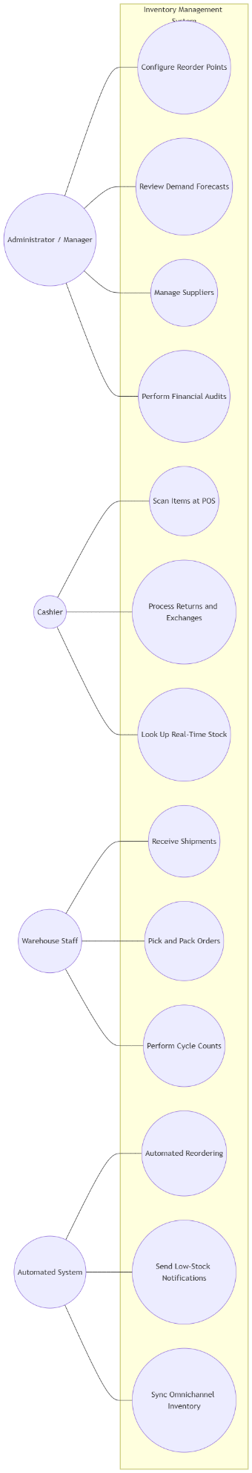

Class Diagram: Structure and Data Persistence
The Class Diagram provides a static view of the system's entities, their attributes, and their relationships, serving as a blueprint for the underlying PostgreSQL databases.⁵⁴
- Product: Attributes include SKU, name, category, description, unit_price, and cost. It maintains an association with Supplier.¹²
- InventoryItem: Represents a physical unit in a specific location. Attributes include item_id, warehouse_id, quantity_on_hand, quantity_reserved, and reorder_threshold.⁴⁷
- Order: Manages the transaction lifecycle. Attributes include order_id, customer_id, order_date, total_amount, and status (e.g., PENDING, PAID, CANCELLED).⁴³
- Supplier: Tracks vendor details. Attributes include supplier_id, name, lead_time, and rating.¹⁶
The architecture follows the "Database per Service" pattern, ensuring that the Inventory class and Order class reside in separate schemas. Communication between these entities occurs via APIs and the message bus rather than direct foreign key constraints, ensuring loose coupling.¹
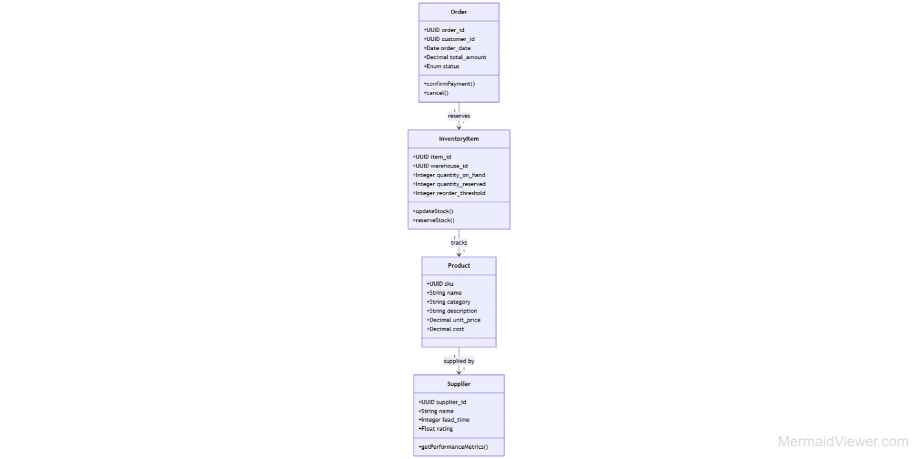

Activity Diagram: Workflow Logic
Activity Diagrams are utilized to model the dynamic flow of business processes, such as the "Detect-to-Replenish" cycle.³⁶
- Start: Inventory Service detects stock level below the reorder threshold.¹
- Forecast: Analytics Service calculates optimal order quantity based on historical demand.¹³
- Draft: Procurement Service generates a draft Purchase Order.¹⁶
- Review: Manager receives a notification and reviews the PO.³⁶
- Branch: If approved, transmit PO to supplier; if rejected, log reason and terminate.³⁶
- Fulfill: Supplier ships goods; Warehouse Staff scans shipment upon arrival.¹³
- Update: Inventory Service updates stock-on-hand and releases the PO.¹²
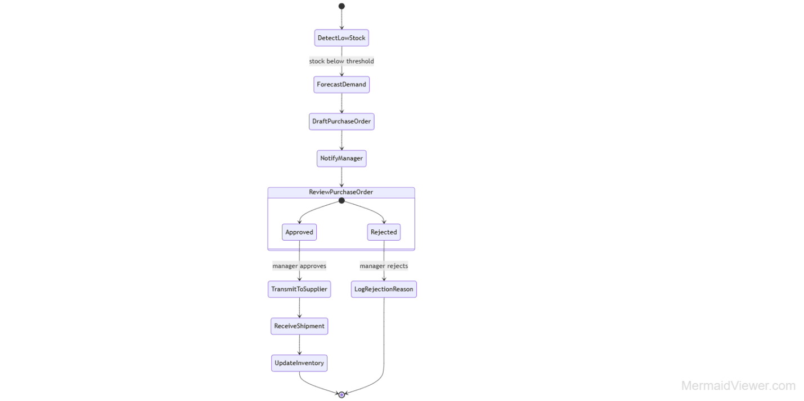

State Diagram: Entity Lifecycles
State Machine Diagrams model how an object, such as an Order, changes its state in response to events and time-based triggers.⁵⁹
- Initial State: [*] → Pending (Order created; stock reserved; waiting for payment).⁴⁰
- Transition 1: payment_received event → Paid (Triggers fulfillment picking).³⁹
- Transition 2: shipping_confirmed event → Shipped (Triggers notification to customer).²⁶
- Final States: Delivered (Success) or Cancelled (Triggered by payment timeout or stock unavailability). A transition to Cancelled initiates a compensating transaction to release the reserved stock.¹
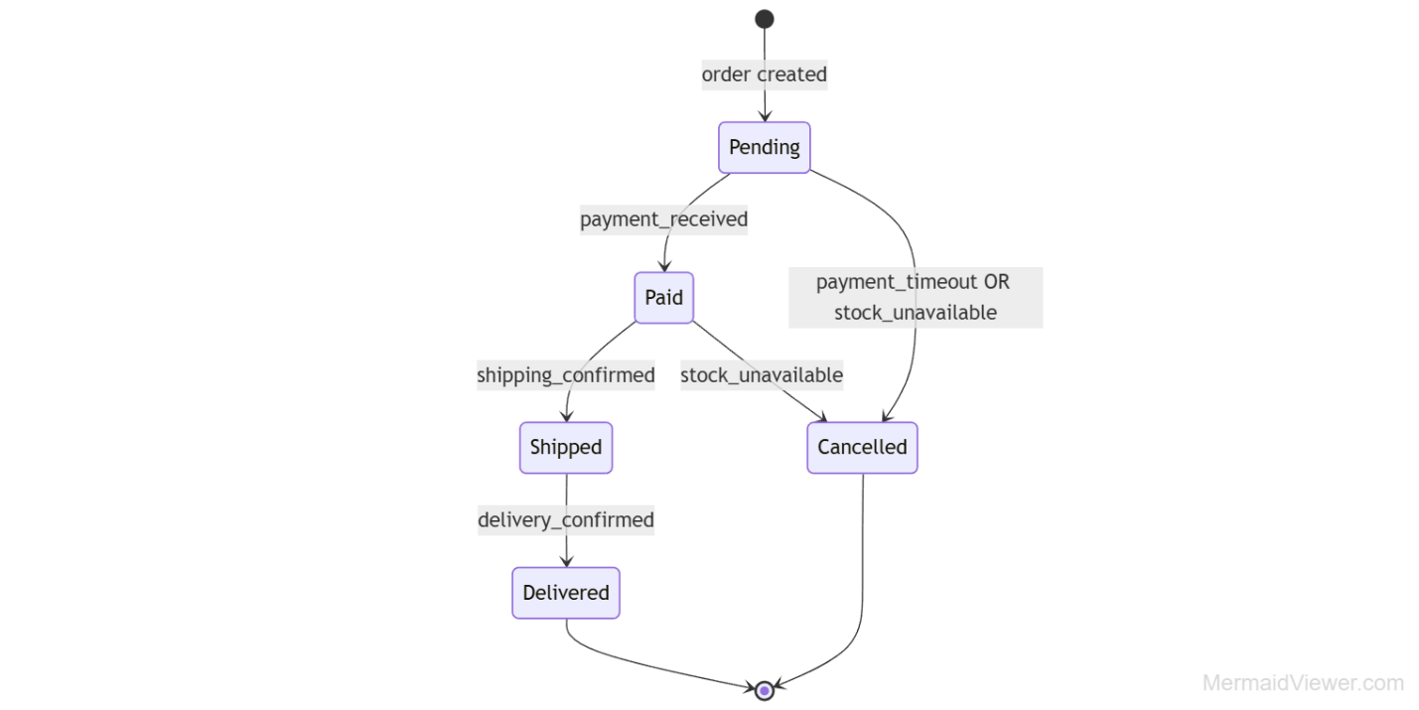

Sequence Diagram: The Order-Inventory Saga
The Sequence Diagram illustrates the time-ordered interaction between services, particularly how the system maintains data consistency through the Saga pattern in a distributed environment.⁴⁰
- Order Request: The Client sends POST /orders to the API Gateway.²⁶
- Order Persistence: The Order Service creates an order in PENDING state and publishes an OrderCreated event to the message bus.³⁹
- Stock Verification: The Inventory Service consumes OrderCreated, checks availability, and reserves the stock. It then publishes StockReserved.¹
- Payment Initiation: The Payment Service consumes StockReserved and processes the customer's credit card. It then publishes PaymentSucceeded.³⁹
- Final Commitment: The Order Service consumes PaymentSucceeded, updates the order to PAID, and triggers the fulfillment workflow. If payment fails, it publishes PaymentFailed, prompting the Inventory Service to release the reservation.¹
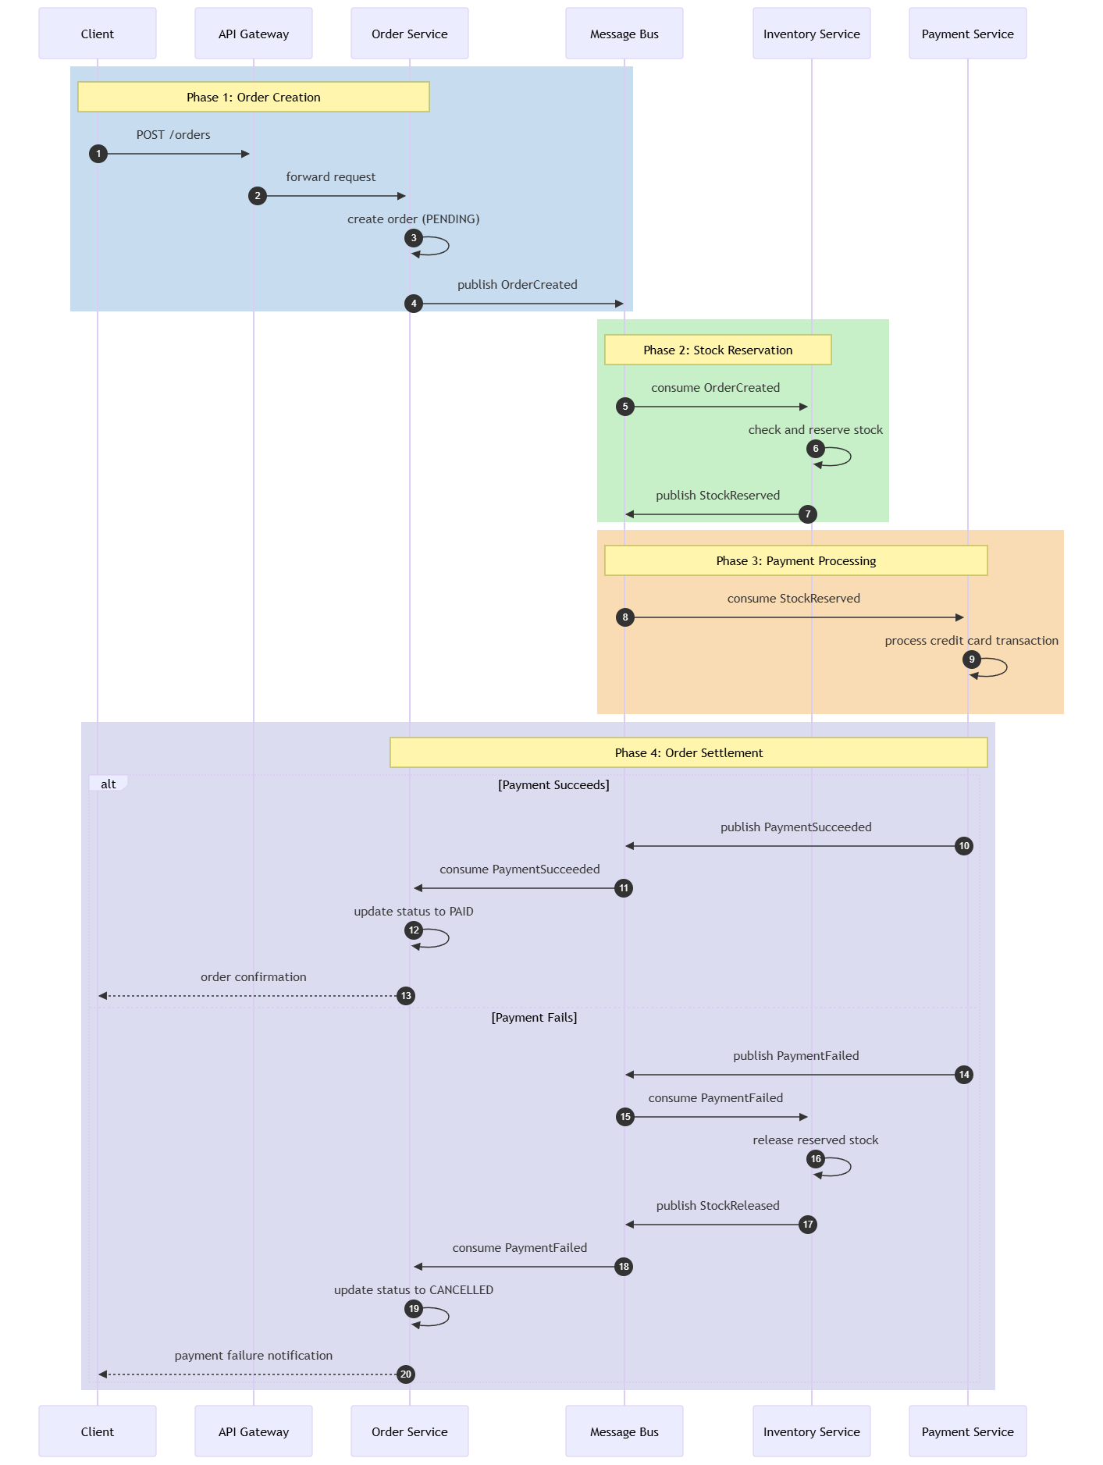

Strategic Work Breakdown Structure (WBS)
The Work Breakdown Structure (WBS) provides a hierarchical decomposition of the total project scope, ensuring that every deliverable is accounted for and manageable.⁶² This structure follows the "100% rule," capturing the entirety of the work necessary for a successful Phase 2 deployment.⁶²

WBS Level 1: Project Phases

WBS Code | Element Name | Description
1.0 | System Architecture & Design | Finalization of high-level and detailed architecture, including service boundaries and data management strategies.¹
2.0 | Microservices Development | The construction of independent services using a "Database per Service" approach and containerization.¹
3.0 | Integration & Middleware | Deployment of the API Gateway, message bus infrastructure, and external adapters.¹
4.0 | Infrastructure & DevOps | Configuration of Kubernetes clusters, CI/CD pipelines, and observability tools (Prometheus/Grafana).¹
5.0 | Deployment & Operational Readiness | Data migration, staff training, and the final 48-hour implementation roadmap.¹

WBS Level 2 & 3: Detailed Deliverables
Within the Microservices Development (2.0) phase, tasks are broken down by domain:
- 2.1 Inventory Service: (2.1.1) PostgreSQL schema design with optimistic locking; (2.1.2) Multi-location stock logic; (2.1.3) Event publishing for stock movements.¹
- 2.2 Order Management Service: (2.2.1) Saga orchestration/choreography implementation; (2.2.2) Order state machine logic; (2.2.3) Invoice generation module.⁴⁰
- 2.3 Analytics & Forecasting Service: (2.3.1) ML model selection and training; (2.3.2) Reorder point calculation engine; (2.3.3) KPI dashboard development.¹³
Under Deployment & Readiness (5.0):
- 5.1 Data Migration: (5.1.1) SME legacy data cleansing; (5.1.2) Bulk SKU upload; (5.1.3) Stock-on-hand validation.¹
- 5.2 Operational Training: (5.2.1) Cashier POS training; (5.2.2) Warehouse mobile app onboarding; (5.2.3) Management dashboard coaching.¹

Implementation Roadmap and 48-Hour Gantt Analysis
The "48-hour implementation capability" is a core differentiator of the proposed solution, addressing the SME's need for rapid modernization with minimal business disruption.¹ This roadmap leverages pre-built cloud-native templates and automated deployment scripts to move from zero to production in a single weekend.¹

Rapid Deployment Timeline (Gantt Structure)
The implementation is divided into four distinct 12-hour blocks, ensuring that each phase is completed before the next set of dependencies begins.⁶⁵

Timeframe (Hours) | Phase | Key Tasks and Milestones
00 - 12 | Infrastructure Provisioning | Tasks: Deploy Kubernetes cluster via IaC (Terraform); provision managed PostgreSQL and Redis instances; set up Kafka message bus. Milestone: Infrastructure Readiness.¹
12 - 24 | Service Deployment & Integration | Tasks: Deploy containerized microservices; configure Kong API Gateway with JWT security; activate Square/Shopify/Xero adapters. Milestone: System Connectivity.¹
24 - 36 | Data Migration & Validation | Tasks: Execute automated data import scripts for SKUs and initial stock; perform reconciliation against physical counts; run end-to-end transaction tests. Milestone: Data Integrity.¹
36 - 48 | User Adoption & Go-Live | Tasks: Role-based staff onboarding; activation of real-time mobile apps; final cutover of the POS system. Milestone: System Live and Operational.¹

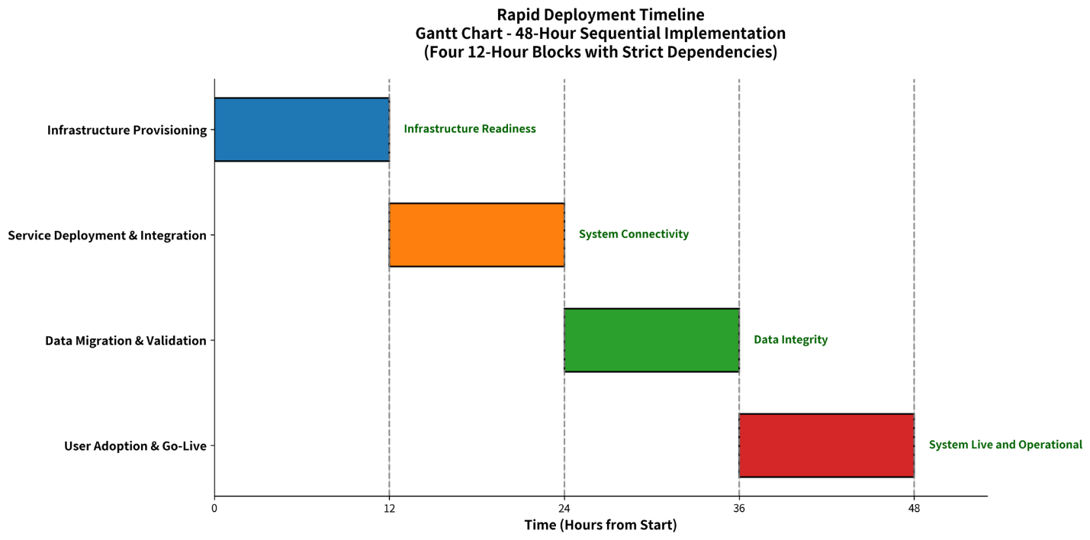

Analysis of Implementation Risks
The speed of this implementation necessitates a high degree of "operational readiness".⁶⁴ The primary risks identified include data migration errors from legacy spreadsheets and potential network bottlenecks during initial synchronization.¹ To mitigate these, the system includes rollback procedures and automated health checks that validate service status at every stage of the rollout.¹ Furthermore, by establishing a "Baseline" comparison, the enterprise can monitor actual progress against the 48-hour plan, identifying any delays in vendor connections or hardware setup early.¹¹

Strategic Insights and System Implications
The proposed transition from manual, legacy systems to a cloud-native, microservices architecture represents a fundamental shift in how SMEs manage their most significant asset: inventory.¹ Analysis of current market solutions confirms that existing platforms suffer from a "solution gap," where basic cloud tools lack the real-time depth required for growth, and enterprise ERP systems are prohibitively complex and expensive for SMEs.¹ By adopting an event-driven design, the enterprise achieves true real-time visibility, eliminating the sync delays that lead to overselling and missed fulfillment targets.¹
The second-order implication of this architecture is the transformation of inventory from a "cost center" into a "strategic driver." With AI-powered forecasting and real-time turnover analysis, SMEs can move toward a Just-in-Time (JIT) model, significantly reducing carrying costs—typically 20% to 30% of average inventory value—and freeing up working capital for growth.¹ Furthermore, the alignment with Industry 4.0 principles, such as elastic scalability and composable API-first design, ensures that the enterprise is future-proofed against further digital disruptions.¹
In conclusion, the meticulous mapping of business processes, the rigorous definition of ISO 25010 non-functional requirements, and the detailed IPO and UML modeling provided in this Phase 2 report establish a robust technical foundation. When coupled with the strategic WBS and the rapid 48-hour implementation roadmap, the SME is positioned to achieve a projected return on investment of 2,446%.¹ This technological integration does not merely improve efficiency; it provides the competitive resilience necessary for SMEs to thrive in an increasingly automated and data-driven global retail marketplace.

